Telecom Cyber India Compliance for Log360
Strengthen data protection and meet Telecom Cyber India compliance with Log360.
Region: India | Type: Data Privacy, Incident Management, Telecommunications | Category: Compliance | Pricing: Free

Overview
The Telecom Cyber India compliance extension in Log360 helps organizations meet the Telecommunications (Telecom Cyber Security) Rules, 2024 (India), rules under the Telecommunications Act 2023 requiring telecom entities to comply with cybersecurity standards, establish SOC operations, and report incidents within 6 hours by providing centralized log management, real-time threat detection, and audit trail capabilities. The platform supports Telecom Cyber India requirements for governance, SOC monitoring, incident reporting, access control, network security, vulnerability audits, data protection, and third-party risk.
For Cybersecurity Policy and Governance, Log360 tracks AD policy changes, GPO configurations, user and group auditing, and computer asset changes. To address Security Operations Center (SOC) Monitoring, the platform aggregates Windows system events, EventLog data, FireEye, Trend Micro, and network attack logs for SOC operations. The extension also supports Incident Reporting and Notification by providing capabilities that provides threat detection from FireEye, Trend Micro, McAfee, network attack logs, and Windows threat reports for incident documentation.

Key Features
- Access Control and Network Authentication: Log360 captures Windows and Unix logon/failed logon events, AD and Entra ID MFA logon, and MFA authentication records.
- Network Security and Infrastructure Protection: Log360 audits network device logon, account management, policy changes, attack reports, and firewall security configurations.
- Cybersecurity Audits and Vulnerability Assessment: Log360 provides system event logging, EventLog data, Windows threat detection, and vulnerability scanner integration for audit support.
- Data Protection and Compliance: Log360 tracks file changes, Windows registry modifications, USB storage auditing, Exchange mailbox audit logging, and removable disk activity.
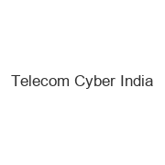
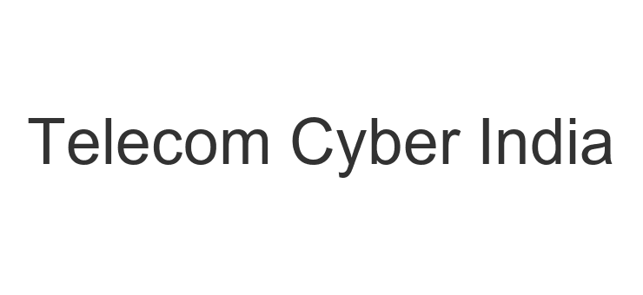
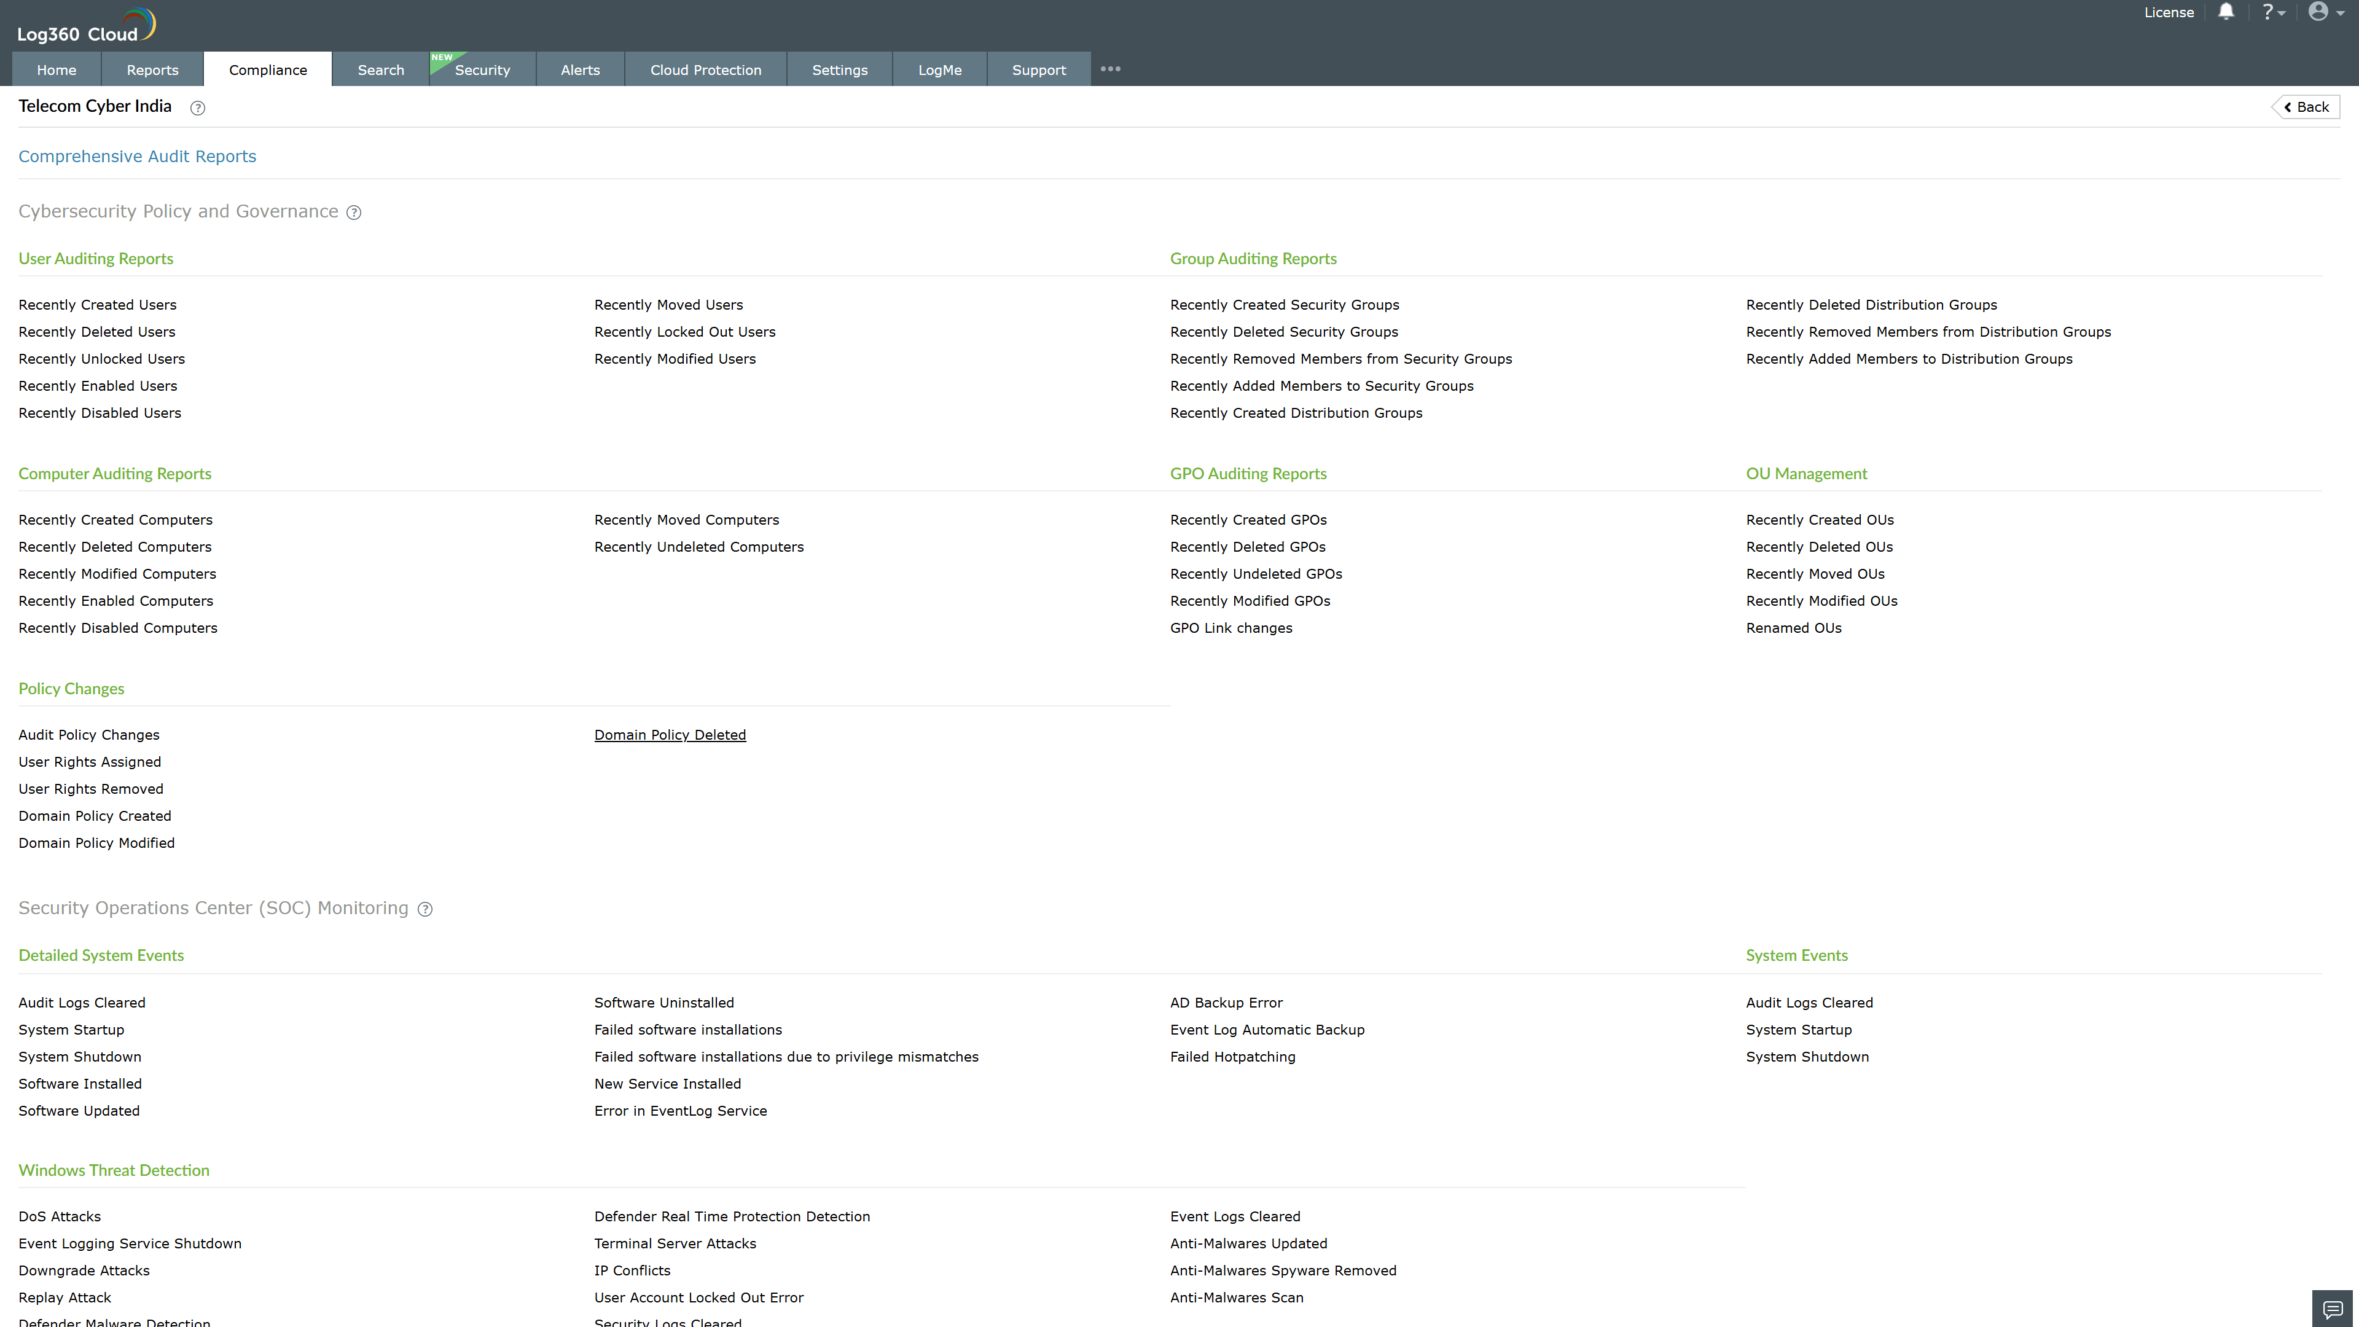
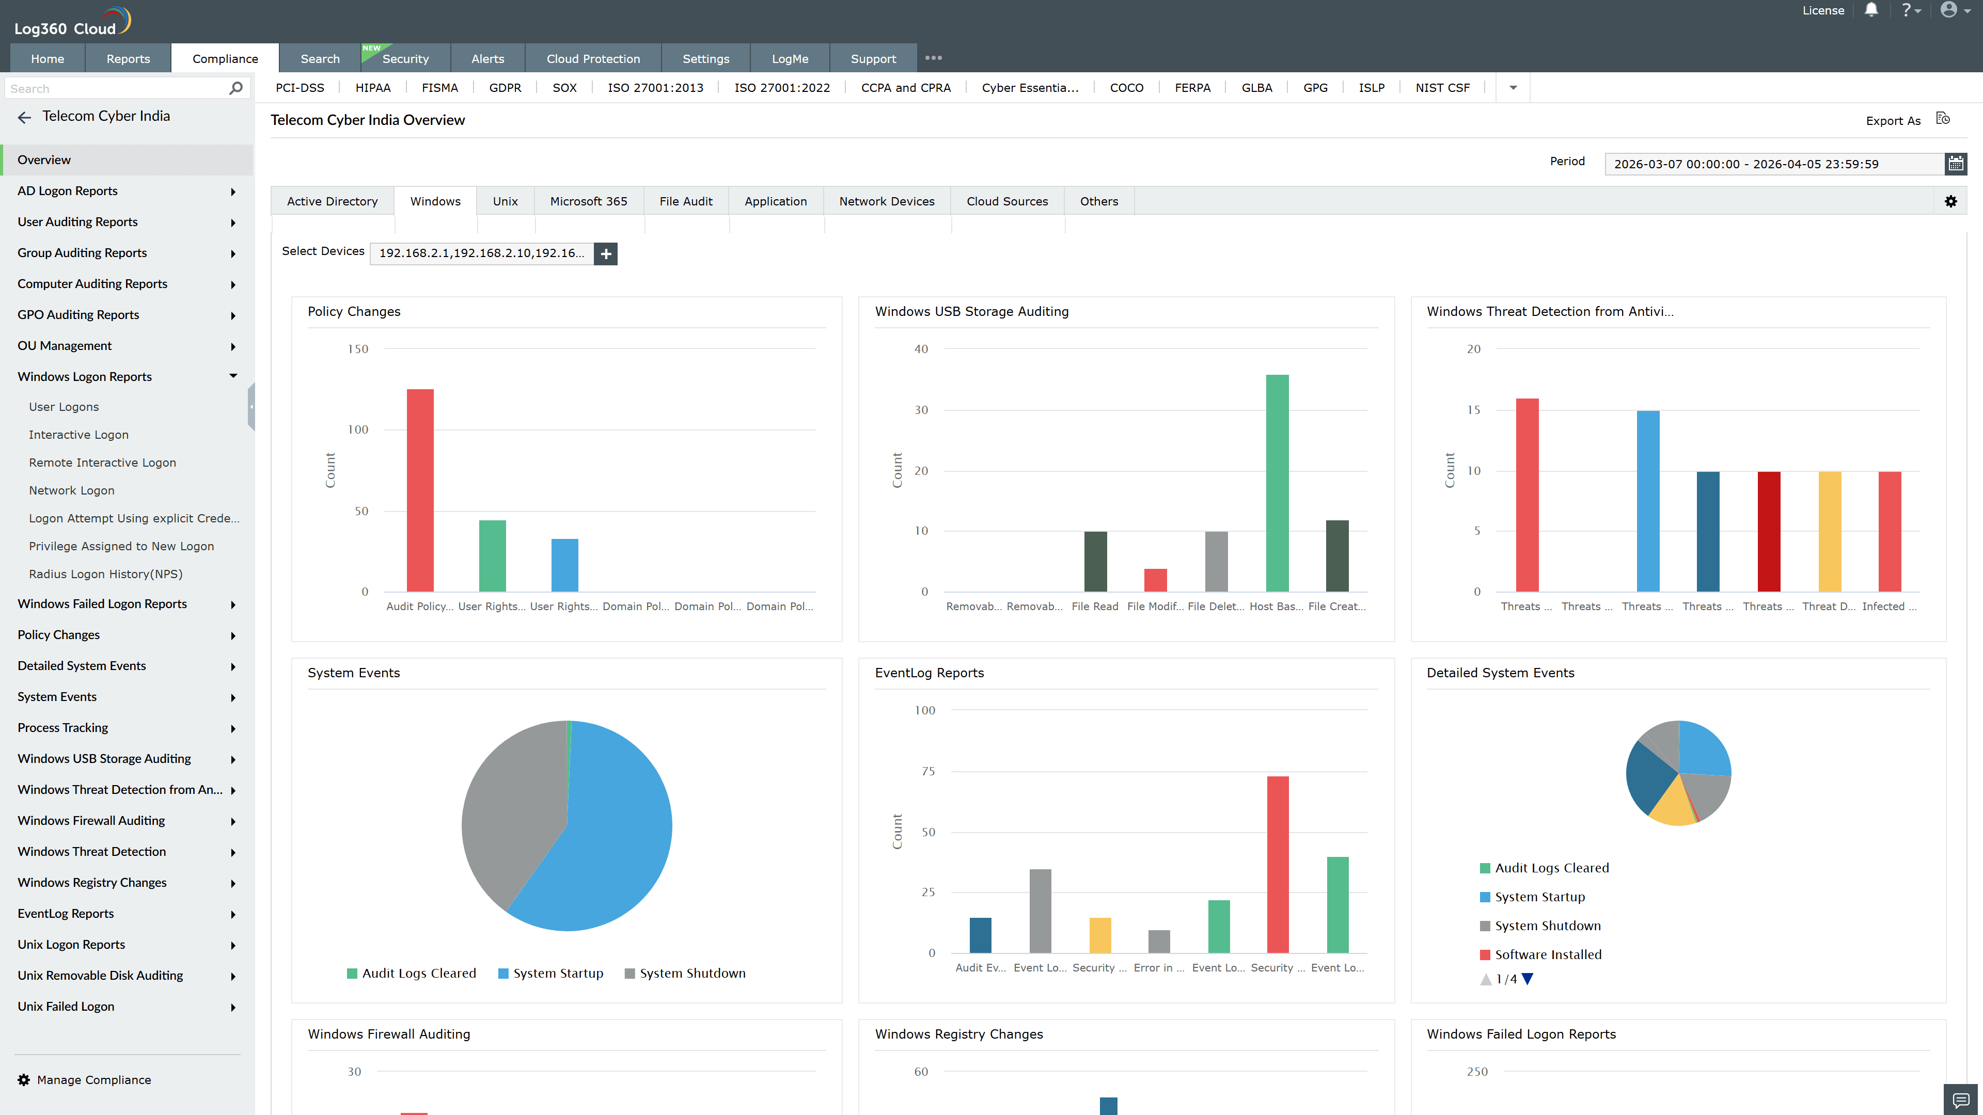
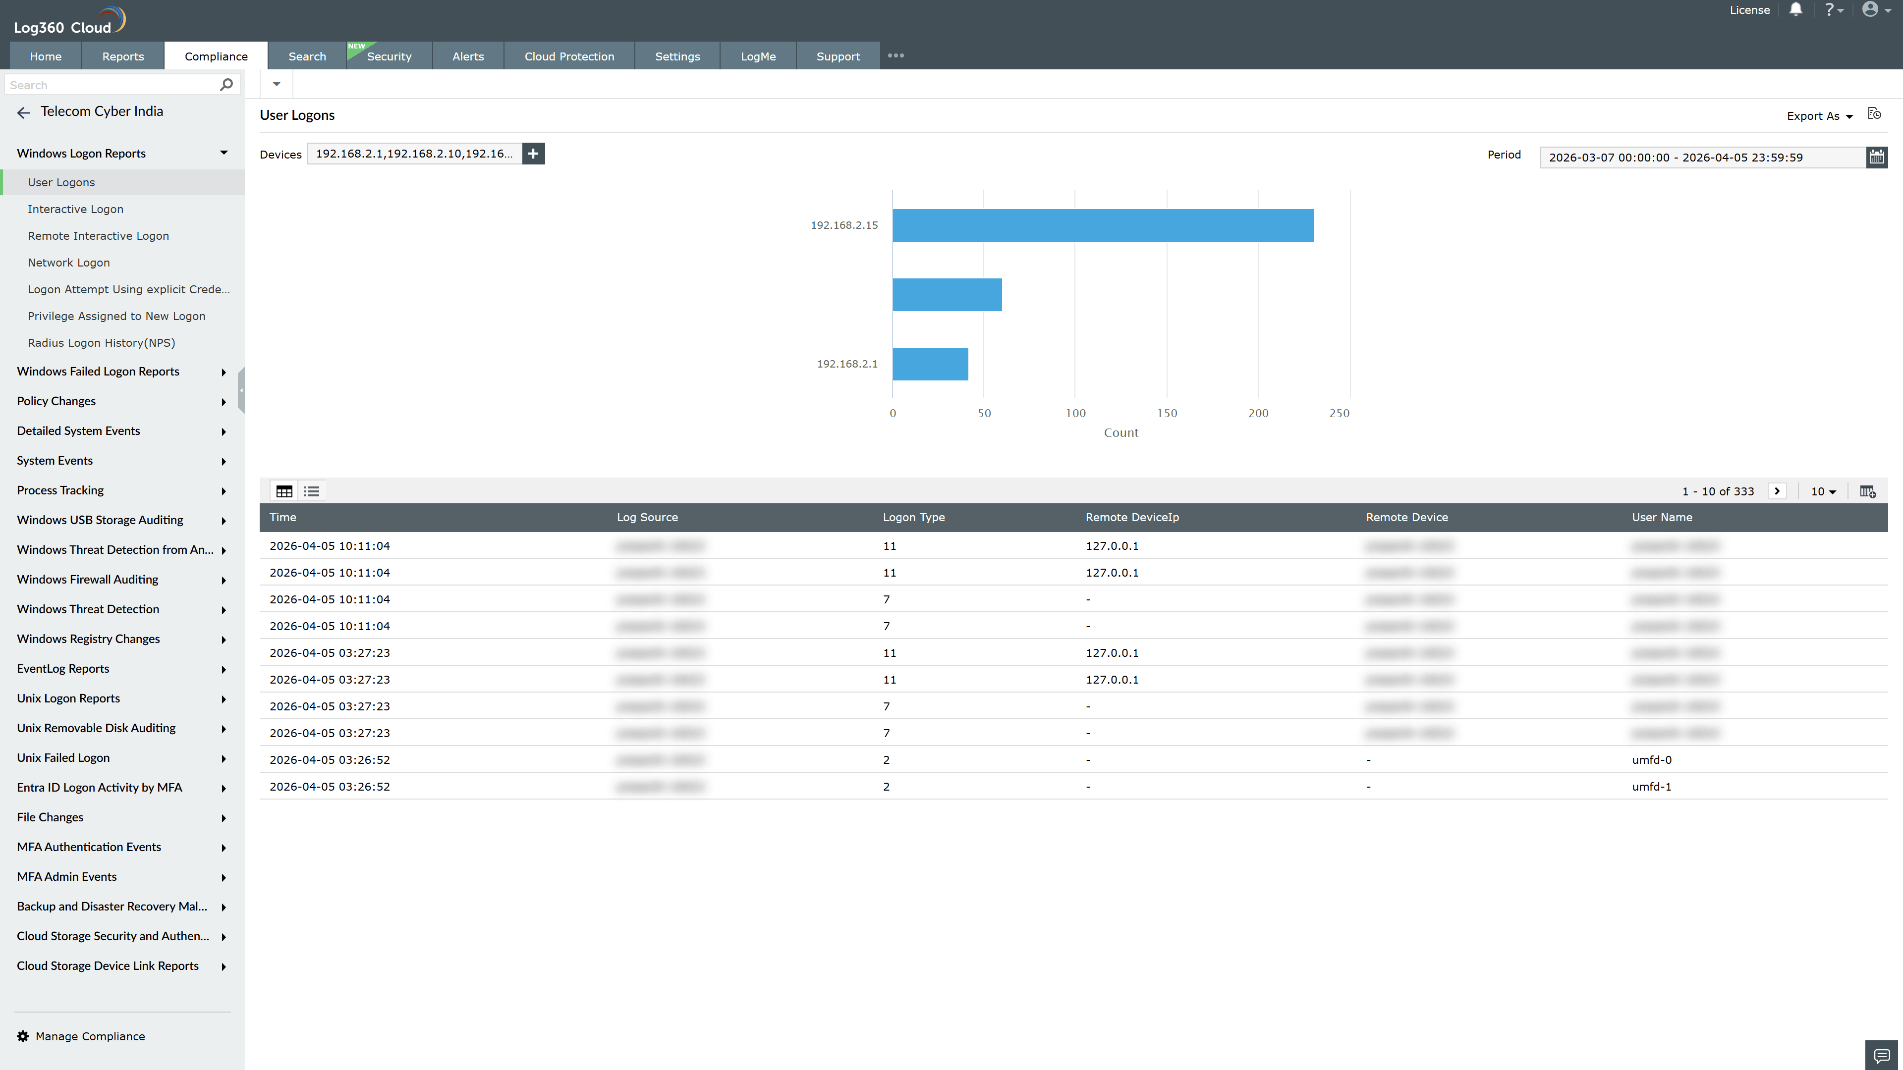
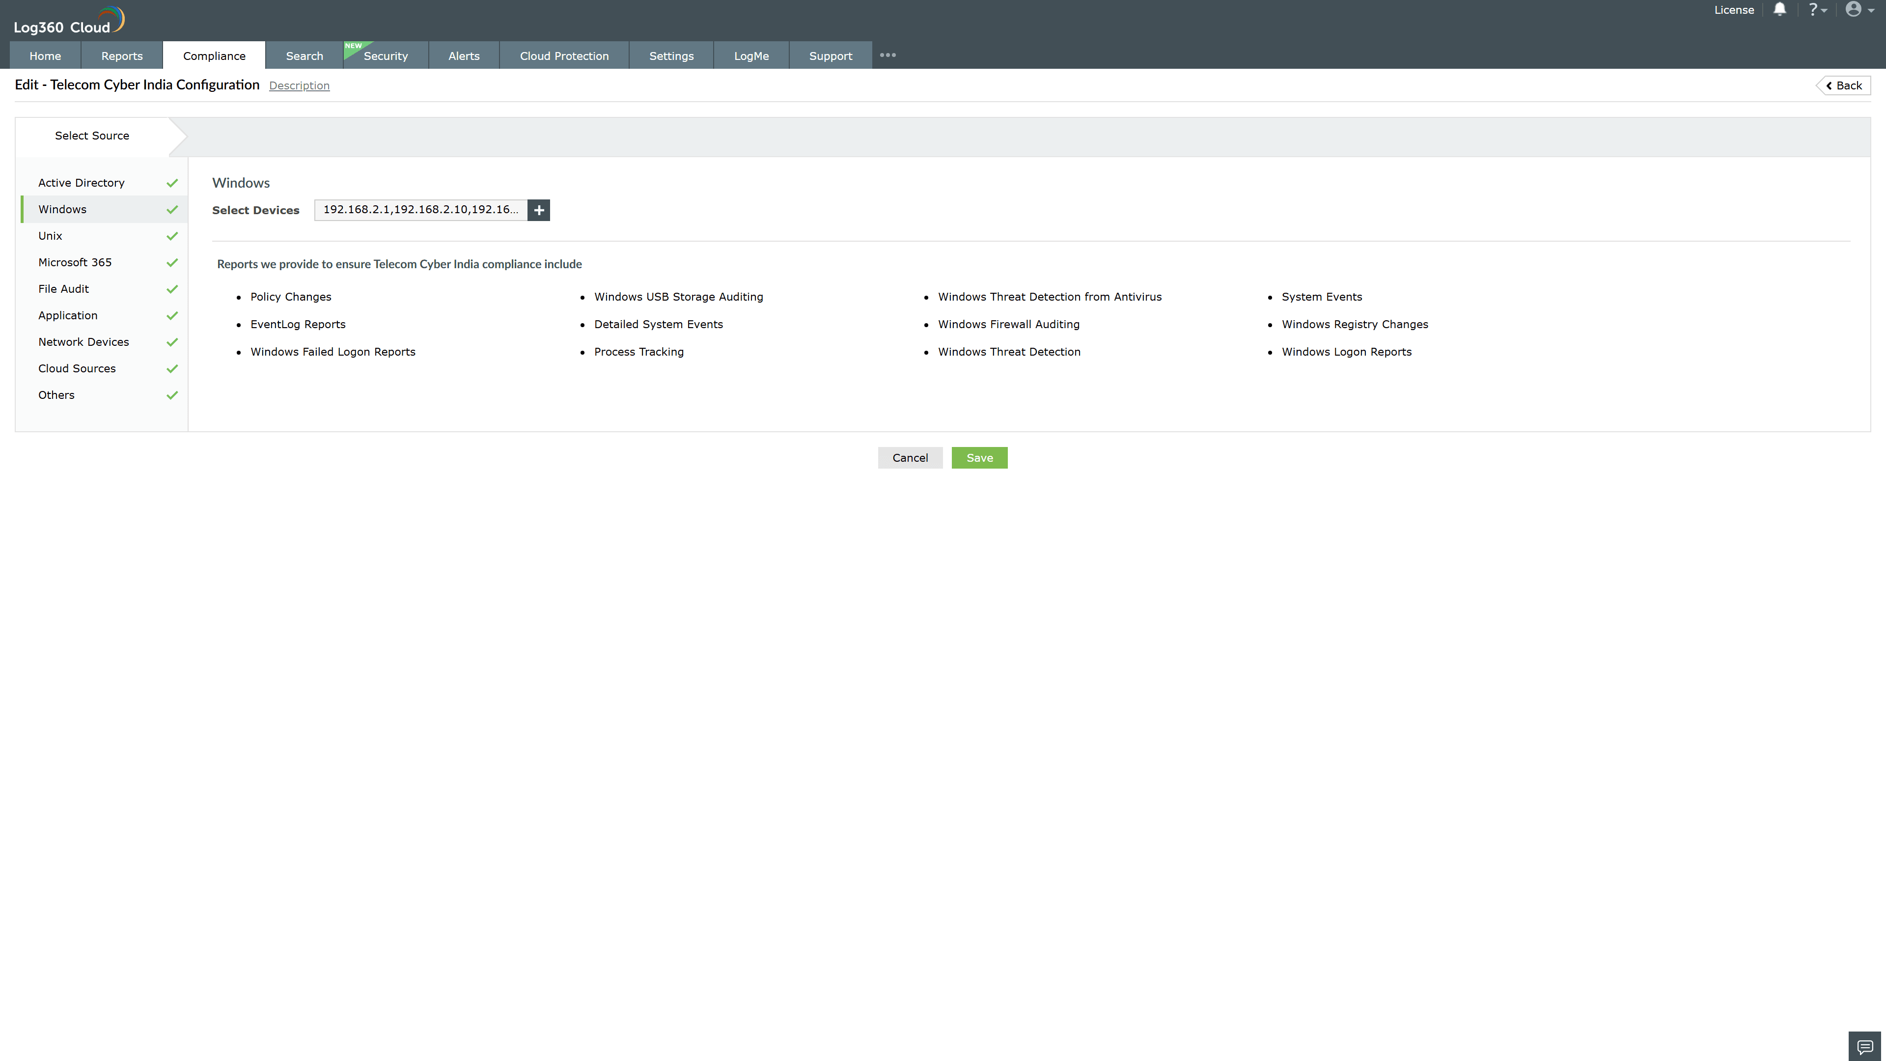
Valid Submission : Yes
Supported Editions : Free, Basic, Standard, Professional, MSSP
Help Document : https://www.manageengine.com/log-management/help/integrations/compliance-extensions.html
Help Video : Not provided
Tags : Log360, Compliance, Privacy monitoring, Data privacy, Regulatory compliance
Supported DCs : US, IN, JP, CA, AU, UK and EU
Privacy Policy:
Terms of Service:
Release Notes:
Predefined reports for the Telecom Cyber India.

